ARTICLES OF ASSOCIATION

OF
CHANDANA VILLA (PVT) LTD

A. Shares

1. Issue of Shares
Subject to the provisions in articles 1 (2) and 1 (3), the board of directors has the authority to issue shares to individuals as it sees fit, in accordance with section 51 of the Companies Act, No. 07 of 2007. If the shares being issued grant any rights beyond those specified in subsection (2) of section 49 or impose obligations upon the holder, the board must approve and clearly state the terms of issue, detailing the rights and obligations attached to those shares as required by subsection (2) of section 51.
Before issuing shares, the board must determine the consideration for which the shares will be issued, ensuring that the value is fair and reasonable both to the company and its existing shareholders.
If new shares are to rank equally with or prior to existing shares, they must first be offered to current shareholders in a way that, upon acceptance, would preserve their relative voting and distribution rights. This offer must remain valid for a reasonable period.

2. Calls on Shares
Where a share requires the holder to pay a sum of money, the holder must pay either on a fixed date or upon request by the board. If called upon, the board will issue a written notice specifying a payment period of no less than twenty working days. Payments not made by the due date will accrue daily interest at a rate set by the board, not exceeding ten percent per annum. The board may choose to waive this interest.
Joint holders of a share are jointly and severally responsible for making any required payments.
The company holds a lien on every share requiring payment and on any distributions payable for amounts currently due in respect of that share. The company may sell any shares on which it holds a lien if notice of intent to sell is given to the shareholder and payment is not made within ten working days of this notice. Transfer of these shares may be signed by a person appointed by the board, and the purchaser's title will not be affected by any irregularity or invalidity in the sale process.
Sale proceeds will first cover the costs of sale, then the outstanding payment, with any surplus paid to the person entitled to the shares at the time of sale.

3. Distributions
The company may make distributions to shareholders following section 56 of the Act. Every dividend must be approved by the board and by ordinary resolution of shareholders, unless the board approves an interim dividend justified by profits, in which case no resolution is required. The board must be satisfied that the company meets the solvency test immediately following any distribution, and directors who support the distribution must sign a certificate of their opinion to that effect.
The solvency test is met if the company can pay its debts as they become due and the value of its assets exceeds its liabilities and stated capital.

4. Share Register, Share Certificates, and Transfer and Transmission of Shares
The company is required to maintain a share register in compliance with section 123 of the Act, located at its registered office or elsewhere in Sri Lanka as notified to the Registrar. Share transfers must be executed via a signed transfer form delivered to the company, and the transferee must also sign if the share imposes a liability.
The board may refuse to register a transfer within six weeks of receipt if any payment due on the share remains unpaid, and must notify the shareholder of the refusal within one week of the decision.
Upon the death of a joint holder, the surviving holders are treated as the holders of the share. In the case of a sole holder's death, the legal representative is recognized as having title or interest in the share.
Any individual who becomes entitled to a share due to death, bankruptcy, insolvency, or incapacity of a shareholder may be registered as the holder upon written request and satisfactory proof to the board. The board may refuse registration as provided earlier.
The company must issue and deliver a share certificate within two months of issuing shares or registering a transfer.

B. Meetings of Shareholders

5. Rules for Meetings
Shareholders' meetings may determine their own procedures unless otherwise governed by these articles.

6. Notice of Meetings
Written notice stating the time and place of a shareholders' meeting must be given to all shareholders entitled to receive it, as well as every director and the auditor. If a special resolution is to be proposed and the company is not private, notice must be given at least fifteen working days in advance; in other cases, at least ten working days.
Notices must specify the business to be transacted in sufficient detail and include the text of any resolution to be presented. Any irregularity in the notice is waived if all entitled shareholders attend without protest or agree to the waiver.
If a meeting is adjourned for less than thirty days, notice of the adjourned meeting is not required except by announcement at the original meeting.

7. Methods of Holding Meetings
Shareholders' meetings may be held by assembling a quorum at the designated place and time or by audio or audiovisual communication, allowing all participants to hear each other simultaneously.

8. Quorum
No business may be transacted without a quorum. A quorum is present if shareholders or their proxies are able to exercise a majority of the votes for the business at hand. If a quorum is not present within thirty minutes, the meeting is adjourned to the same day the following week or another date as appointed by the directors. At the adjourned meeting, those present or their proxies form a quorum.

9. Chairperson
If elected, the chairperson of the board presides over shareholders' meetings. If absent within fifteen minutes of the meeting's start time, shareholders present may choose a chairperson from among themselves.

10. Voting
At in-person meetings, voting is by voice or show of hands as determined by the chairperson, unless a poll is demanded. At meetings held by audio or audiovisual means, voting is by individual voice assent or dissent. The chairperson's declaration that a resolution is carried is conclusive unless a poll is demanded by at least five shareholders or those representing ten percent of voting rights. A poll may be demanded before or after a vote, with votes counted according to shares held. The chairperson does not have a casting vote.

11. Proxies
Shareholders may vote in person or by proxy. A proxy may attend and participate as if they were the shareholder. Appointment must be made in writing, specifying if it applies to a particular meeting or a set term, and must be received by the company at least twenty-four hours before the meeting.

12. Minutes
The board must ensure minutes are kept of all shareholder meetings. Signed minutes by the chairperson serve as prima facie evidence of the proceedings.

13. Shareholder Proposals
Eligible shareholders may submit resolutions to the company in accordance with section 142. The company is required to circulate the resolution or statement, except in certain circumstances specified in subsections (4) and (5) of section 142.

14. Corporate Representation
A corporate shareholder may appoint a representative to attend meetings in the same manner as appointing a proxy.

15. Votes of Joint Holders
For jointly held shares, only the vote of the first-named shareholder in the register is counted, excluding votes from other joint holders.

16. Loss of Voting Right if Calls Unpaid
If any sum due on a share is unpaid, that share may not be voted at meetings except at interest group meetings.

17. Annual and Extraordinary General Meetings
The board must call an annual meeting once per calendar year, not later than six months after the balance sheet date and not more than fifteen months after the previous annual meeting. The first annual meeting need not be held in the year of incorporation but must be within eighteen months of incorporation. Extraordinary meetings may be called at any time by the board or upon written request by shareholders holding at least ten percent of voting rights. Written resolutions signed by eighty-five percent of shareholders are as valid as those passed at meetings, and the company need not hold an annual meeting if all required actions are completed by resolution. Copies of such resolutions must be sent to non-signing shareholders within five working days, and no prior notice is required for such resolutions.

18. Voting in Interest Groups
Actions affecting share rights under section 99 require approval by special resolution of each relevant interest group.

19. Shareholders Entitled to Receive Distributions and Notice
Shareholders entitled to notice of meetings are those registered on a date fixed by the board or, if none is fixed, those registered at close of business the day before notice is given. The fixed date must not be more than thirty working days before the meeting. The company may prepare a list of eligible shareholders showing shareholdings, available for inspection during business hours. Only registered holders may attend and vote, unless shares have been transferred and the transferee is registered and requests entry on the list before the meeting.

C. Directors and Secretary

20. Appointment and Removal of Directors
Shareholders may set the number of directors by ordinary resolution. Directors may be appointed or removed by ordinary resolution at a meeting or by written resolution. For non-private companies, shareholders may only vote on appointing directors if the resolution is for a single director or, after a separate resolution, for multiple directors together. Directors may resign by signed notice delivered to the registered office, effective upon receipt or as specified. A director vacates office upon resignation, removal, disqualification, death, or upon reaching the age limit as set by law.

21. Powers and Duties of Directors
Except for major transactions under section 185, the board manages the company's business and affairs, holding all necessary powers. The board may delegate powers to committees, directors, or employees as permitted by section 186. Directors are bound by statutory duties, including acting in good faith and in the company's best interest, and must not contravene the Act or these articles.

22. Interested Directors
Directors with an interest in company transactions must disclose this per section 192. A director is considered interested if they benefit materially, have a financial interest in a party, serve as director, officer, trustee of a party, or are related by family, except in specific situations involving company guarantees. Remuneration and indemnity per sections 216 and 218 are excluded. Interested directors may vote, attend meetings, sign documents, and act as directors on the transaction. Directors must not misuse company information except for company purposes, as required by law, or if authorized by the board and recorded in the interests register. Directors must also disclose share dealings as required by law.

23. Meetings of Directors
Articles 24 to 30 specify the procedures for board meetings, which may otherwise set their own procedures.

24. Chairperson
Directors may elect a chairperson for a specified period. If none is elected or present within five minutes, the directors present choose a chairperson for the meeting.

25. Notice of Meetings
Directors, the secretary, or an employee (if requested) may convene board meetings. All directors in Sri Lanka must receive at least twenty-four hours' notice. Irregularities in notice are waived if all directors attend without protest or agree to the waiver.

26. Methods of Holding Meetings
Board meetings may be held in person or by audio/audiovisual means, provided all participants can hear each other.

27. Quorum
A quorum for board meetings is a majority of directors. No business may be conducted without a quorum.

28. Voting
Each director has one vote. The chairperson has a casting vote. Resolutions pass if agreed to by all present directors or by a majority of votes. Directors are presumed to have agreed to resolutions unless they expressly dissent or vote against them.

29. Minutes
The board must ensure minutes of all board meetings are kept.

30. Unanimous Resolution
Written resolutions signed or assented to by all directors entitled to notice are valid as if passed at a meeting. Such resolutions may consist of multiple documents in similar form. Copies must be entered in the board's minute book.

31. Managing Director and Executive Directors
The board may appoint a managing director for any period and terms, and may cancel the appointment. If a managing director ceases to be a director, they also cease to be managing director. Remuneration is as agreed, by salary, commission, profit participation, or any combination. The board may delegate powers to the managing director, subject to conditions and may vary or withdraw delegation at any time. Delegation does not prevent the board from exercising the power unless expressly provided. Other employed directors are paid as agreed.

32. Secretary
The company must always have a secretary. The board may appoint and remove the secretary, and set the terms and remuneration. The secretary may not be the sole director or a corporation where the sole director is also the sole director of the company. Actions required by law to be done by both a director and the secretary cannot be performed by the same person acting in both capacities.

D. Accounts and Audit

33. Accounting Records, Financial Statements, Audit
The board must ensure the company keeps accounting records that accurately record transactions, enable accurate determination of financial position, enable preparation of financial statements per the Act, and facilitate proper auditing. The records must comply with section 148. Financial statements and (if applicable) group financial statements must be completed within five months of the balance sheet date, signed by two directors or the sole director if only one. The company must appoint an auditor annually, who is deemed reappointed unless disqualified, replaced, or declines reappointment. The board must prepare an annual report on company affairs within five months of the balance sheet date, sending it to shareholders no less than twenty working days before the annual meeting.

E. Liquidation and Removal from the Register

34. Resolution to Appoint Liquidator
Shareholders may resolve to wind up the company voluntarily by passing a special resolution.

35. Distribution of Surplus Assets
After all creditors have been paid, surplus assets are distributed among shareholders proportionally to their shareholdings, subject to any share terms. With special resolution approval, the liquidator may divide surplus assets in kind, set fair property values, and determine division among shareholders or classes of shareholders.

F. Miscellaneous

36. Documents to be Kept by the Company
The company must keep at its registered office or an approved location the following documents: certificate of incorporation and articles, minutes of all meetings and resolutions of shareholders and directors or committees for the last ten years, interests register (unless dispensed), certificates given by directors under the Act, register of directors and secretaries, copies of all written communications to shareholders or holders of the same class for the last ten years, annual reports, financial statements for the last ten completed accounting periods, instruments creating or evidencing charges and register of charges, share register, and accounting records for the current and last ten completed accounting periods. References to ten years or ten completed accounting periods may be for a lesser period if approved by the Registrar in writing.

37. Rights of Directors and Shareholders to Documents
Directors are entitled to access company records as per section 118. Shareholders may inspect documents under section 119 as specified in section 121 and may request copies or extracts within five working days of a written request, subject to reasonable fees set by a director or the secretary, with board direction.

38. Name of Company
The company may change its name by special resolution according to section 8.

39. Notices
Documents or notices to shareholders must be sent to their registered address by ordinary post, deemed received within three working days. Shareholders with addresses outside Sri Lanka may designate a Sri Lankan address for correspondence. Notices to joint holders are sent to the first-named holder in the register. If a shareholder dies, becomes bankrupt or insolvent, notices continue to be sent to the registered address unless another is requested. All notices to shareholders must also go to the company auditor.

40. Insurance and Indemnity
The company must indemnify directors, auditors, and secretaries against costs incurred defending proceedings related to their duties, if judgment is in their favor, acquitted, or the proceedings are discontinued. Additional indemnity to directors or employees is permitted as per section 218 if the board deems appropriate.

41. Provisions for Private Companies
For private companies, shares or securities may not be offered to the public, and the company may not have more than fifty shareholders, excluding employees or former employees who became shareholders during employment and remained so. Unanimous shareholder resolution may dispense with the interests register but ceases if any shareholder requests its keeping. Actions agreed or concurred by all shareholders are deemed valid, and certain provisions in the Second Schedule do not apply as per section 31.

42. Interpretation
“The Act” refers to the Companies Act, No. 07 of 2007, and terms defined in the Act have the same meaning in these articles.

Signatures of Initial Shareholders
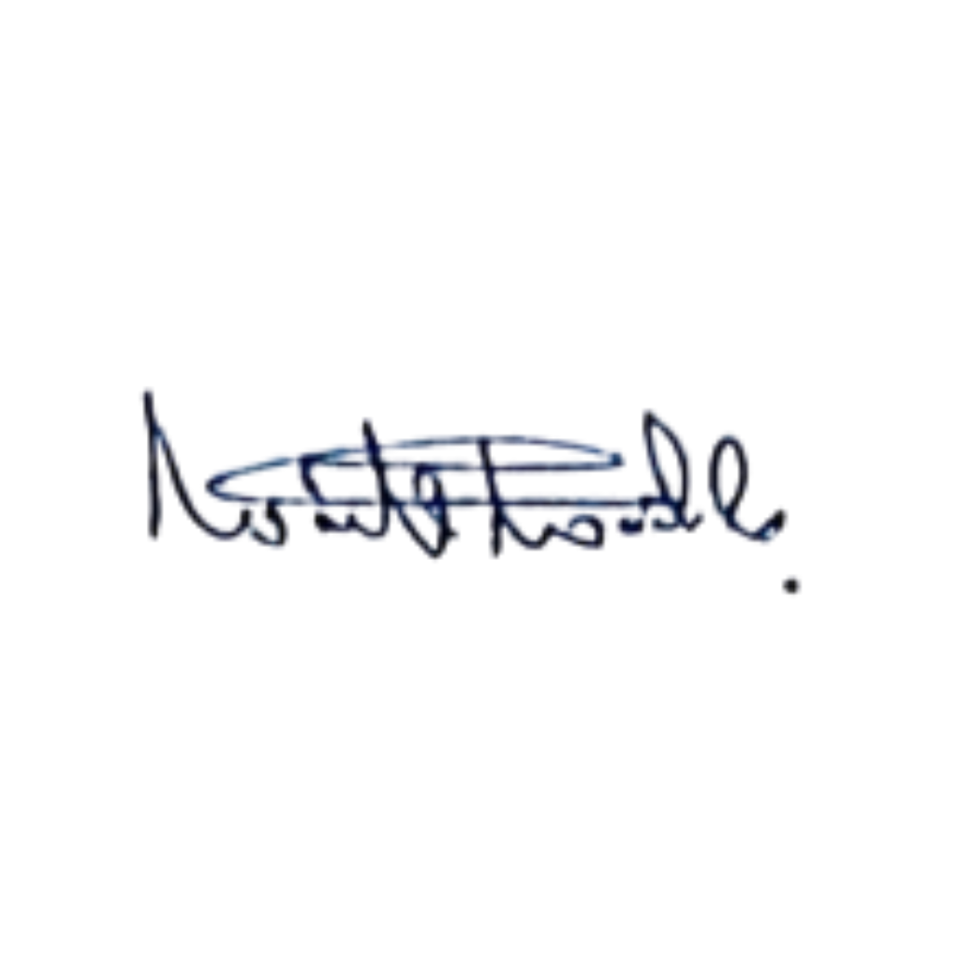
IN WITNESS WHEREOF the initial shareholders have agreed to the foregoing Articles of Association and have set their hands and subscribed their names on this date.
Name | Address & Description | Signature
1. Wanniarachchige Pramuditha Damsara | 390/01, Colombo Road,  Puwakpitiya | 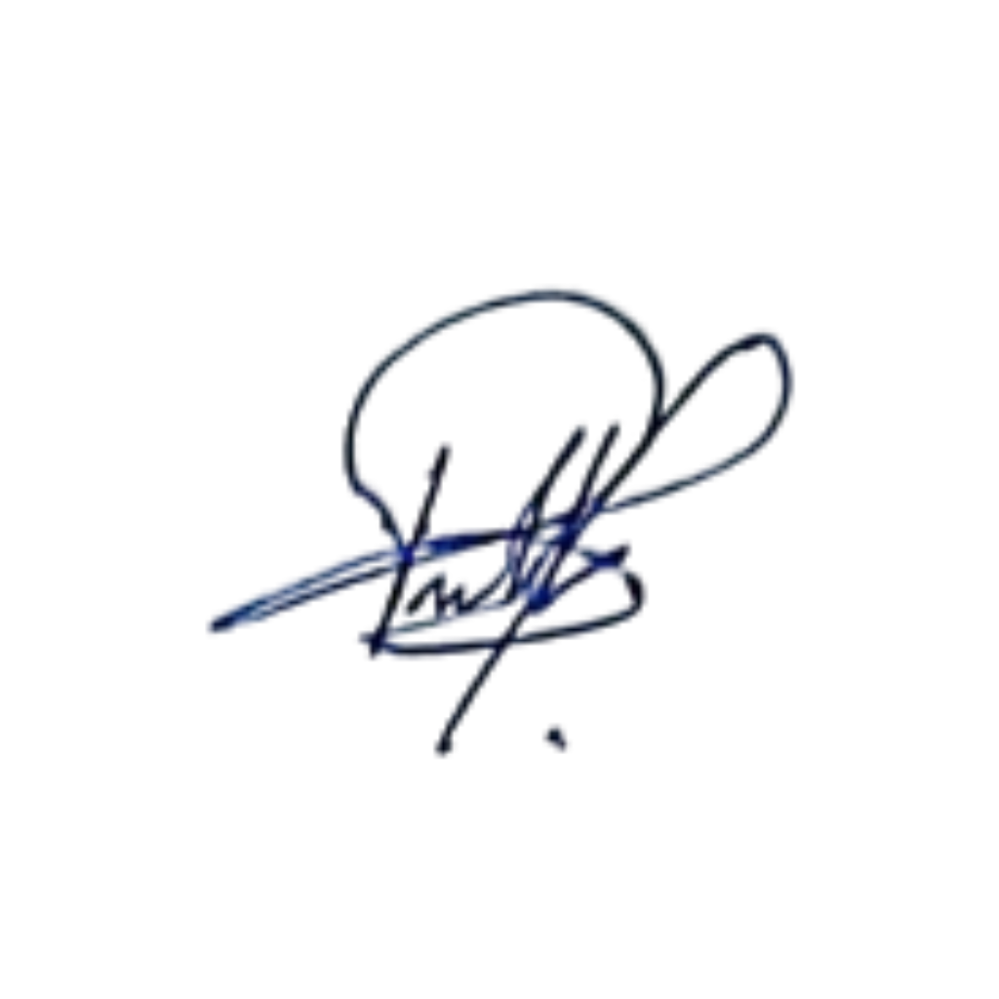
2. Wanni Arachchige Dharmapriya Wasantha Kumara | 390/01, Colombo Road,  Puwakpitiya

Date: 16th May 2026

